*PROJECT – REPORT*

*INDIA’S AGRICULTURE CROP PRODUCTION ANALYSIS(1997-2021)*

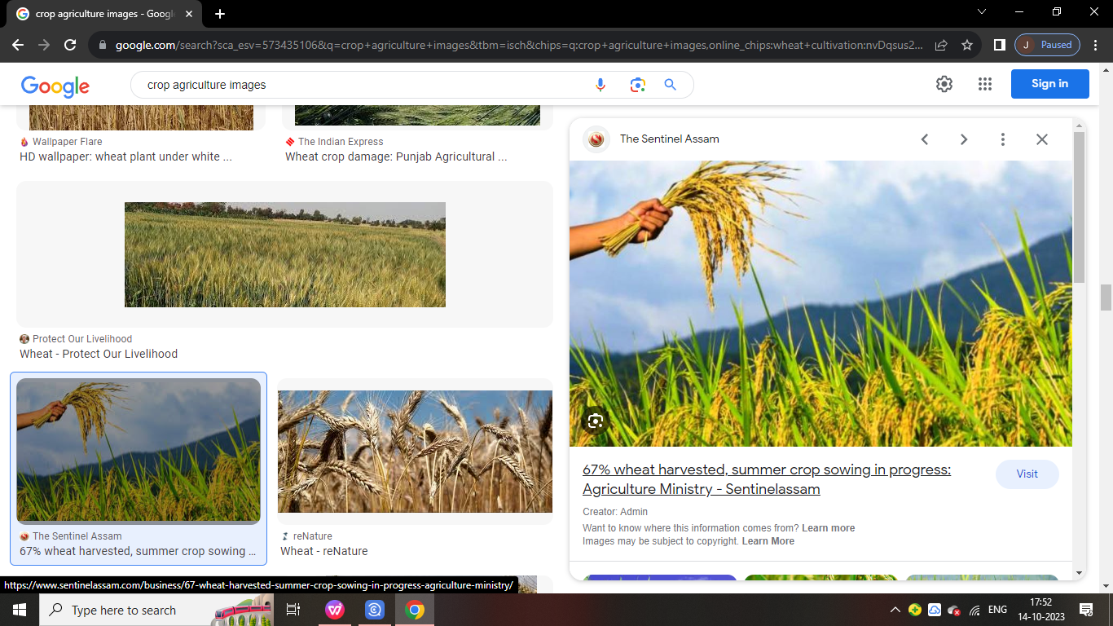

*Team member:(TEAM ID-NM2023TMID06306)*

*B. Jothish kumar (asunm1319222104930)*

*R.Gowri sankar (asunm1319222104922)*

*R.Hari krishna (asunm1319222104927)*

1. *Gajendran (asunm1319222104921)*

*PROJECT FLOW*

* DEFENCE PROBLEM / PROBLEM UNDERSTANDING
* Specify the business problem
* Business requirement
* Literature survey
* DATA COLLECTION AND EXTRACTION
* Collect the data set
* Connect data set with tableau
* DATA PREPARATION
* Prepare the data for visualization
* DATA VISUALIZATION
* No unique visualization
* DASH BOARD
* Response and design of dashboard
* Story
* No of scences of story
* PERFORMANCE TESTING
* Utilization of data filters
* No of calculation fields
* No of visualization / graps
* PUBLISHING
* Publishing dashboard and story to tableau public
* PROJECT DEMONSTRATION
* DOCUMENTATION
* Record explanation video for project end to end solution
* Project documentation step by step project development procedure
* *INTRODUCTION*
* *1.1: OVERWIEW:*
* *produce commodities which maintain life, including food, fiber, forest products, horticultural crops, and their related services".*
* *1.2:PURPOSE:*
* *India is the second-most populous country in the world. And to feed such a huge population, there is always a constant need for a supply of food. Therefore, there is a need for agriculture and a need for less dependency on the agriculture sector for the Economy.*

1. *PRBLEM DEFINITION & DESIGN THINKING*
   1. *Empathy map*

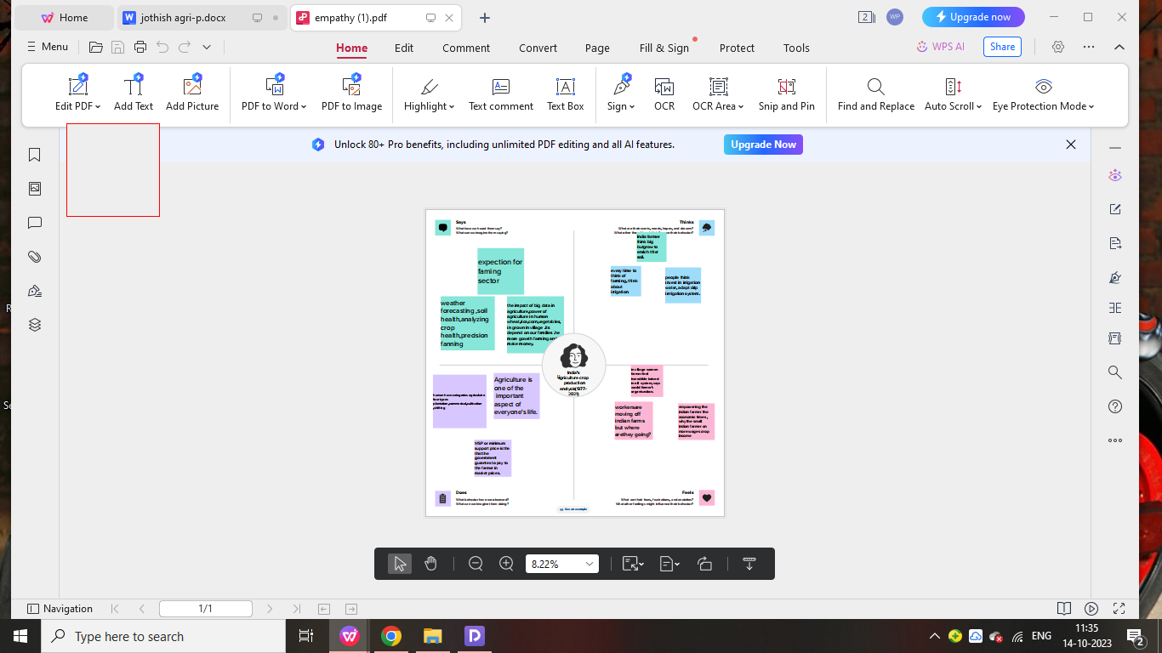

* 1. *IDEATION & BRAINSTORM MAP*



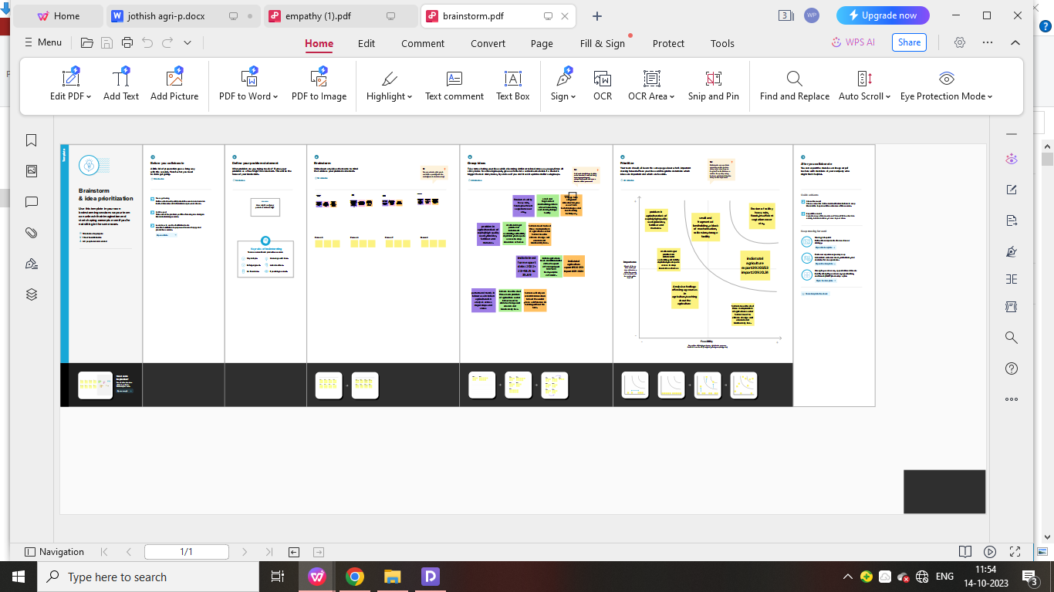

***3: RESULT***

Using tableau software we analysed the dataset of iphone market and have created visualization

# state wise agriculture

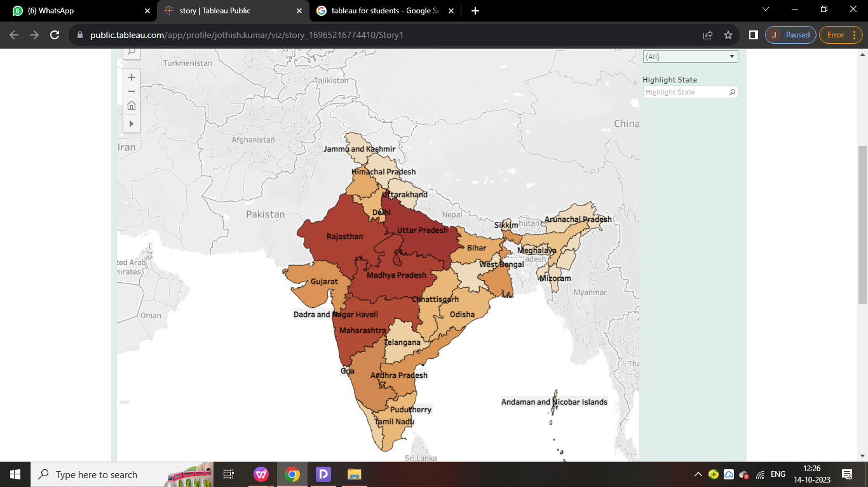

# season based cultivation area

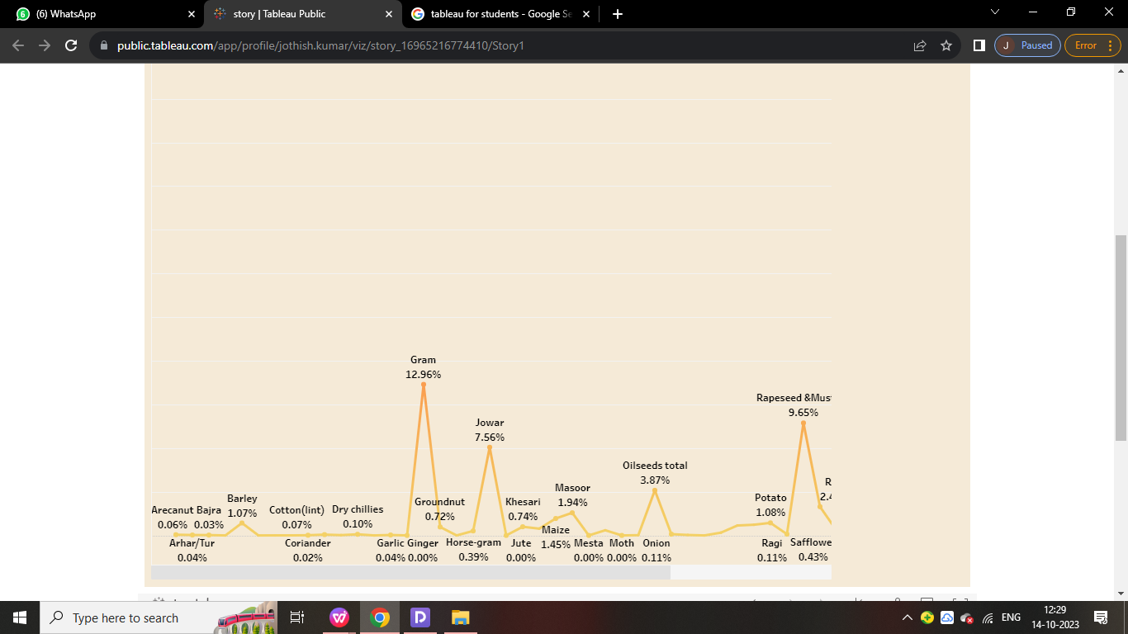

# Yield by season

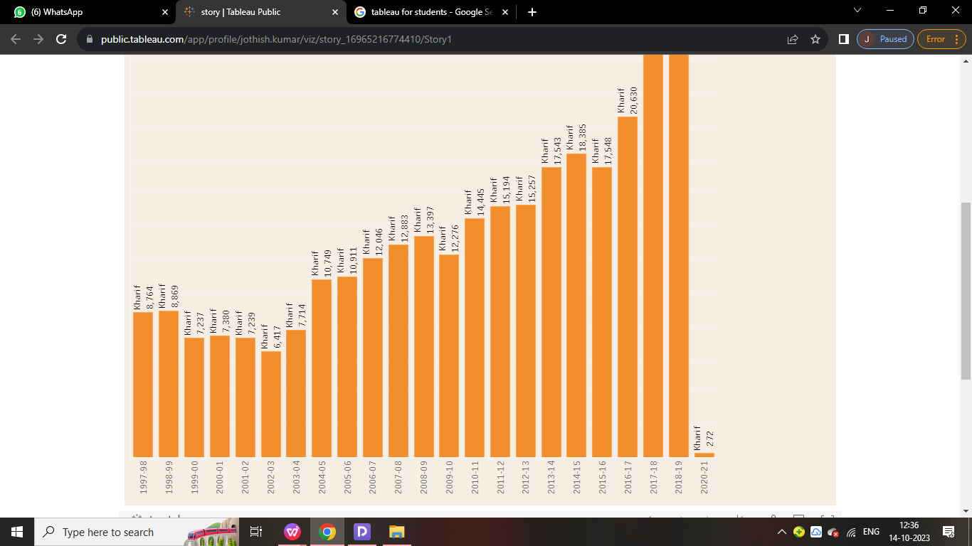

# Crop plantation area

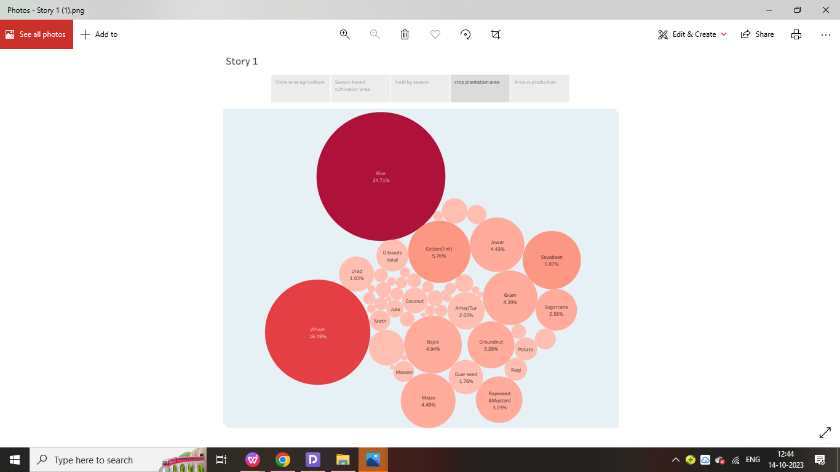

# area vs production

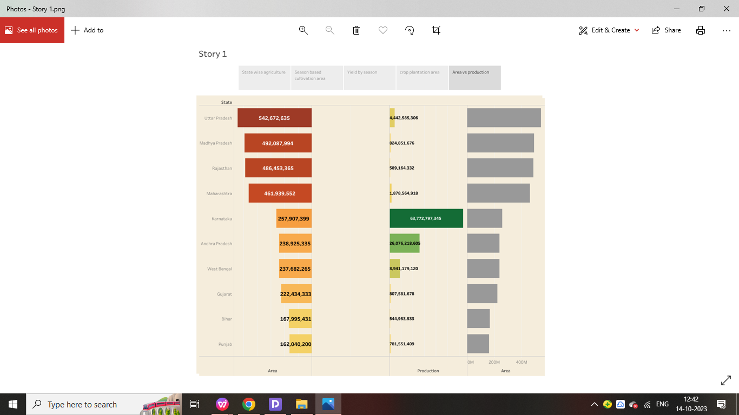

DASHBOARD

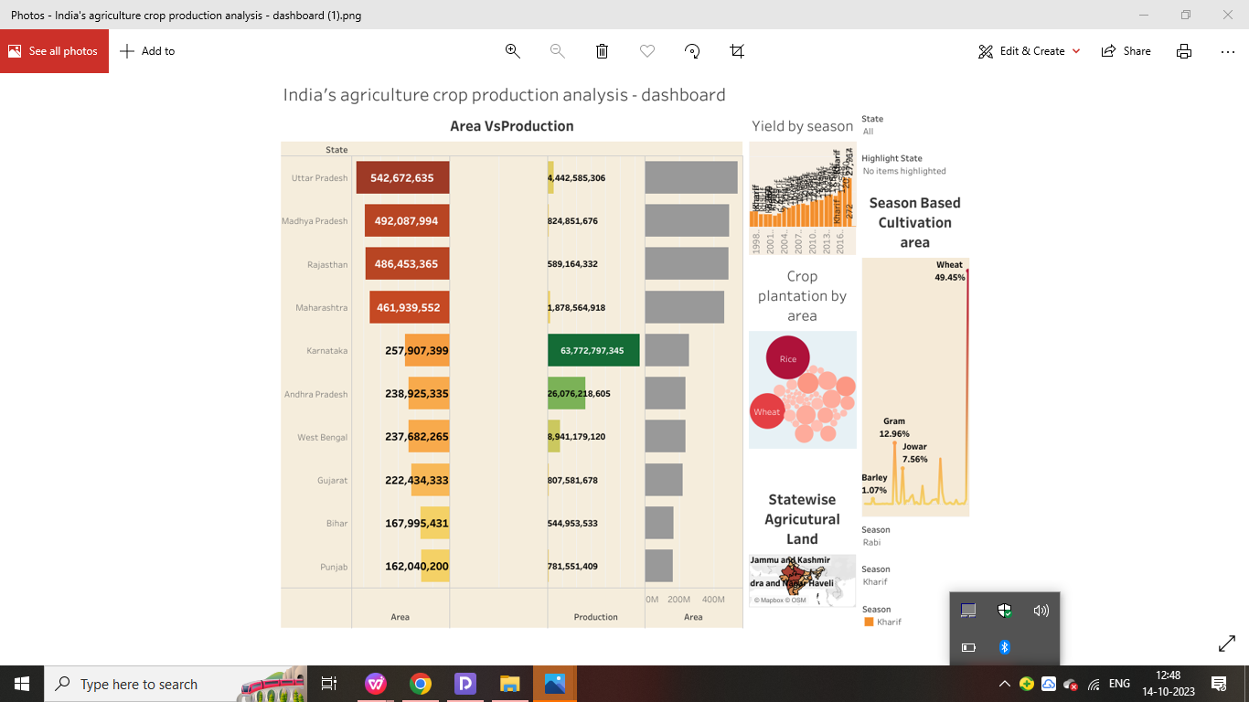

STORY

India’s agriculture crop production analysis (1997-2021)

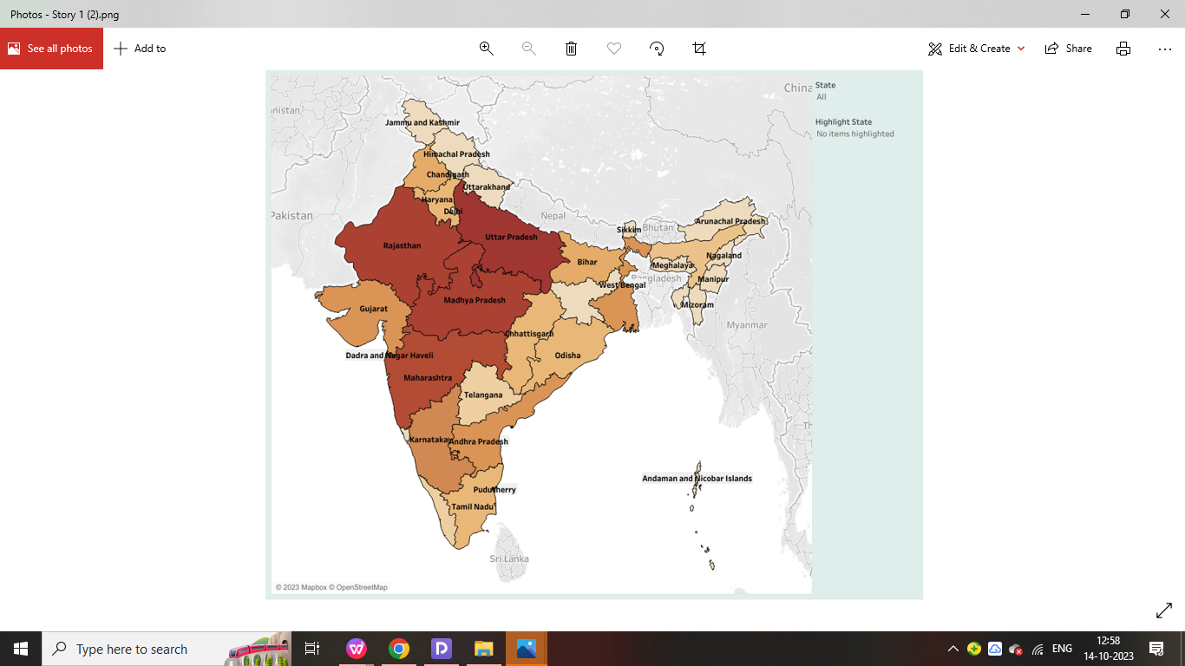

India’s agriculture crop production analysis (1997-2021)

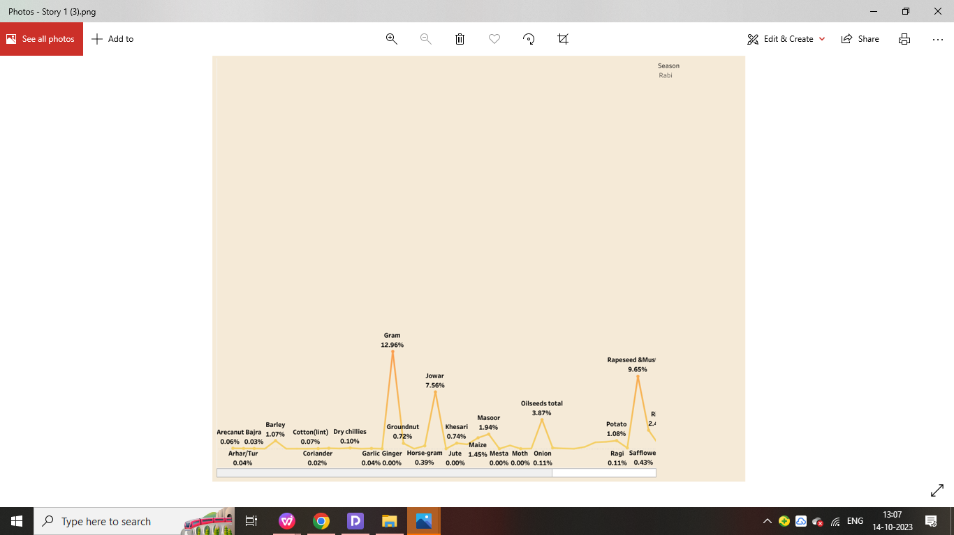

India’s agriculture crop production analysis(1997-2021)

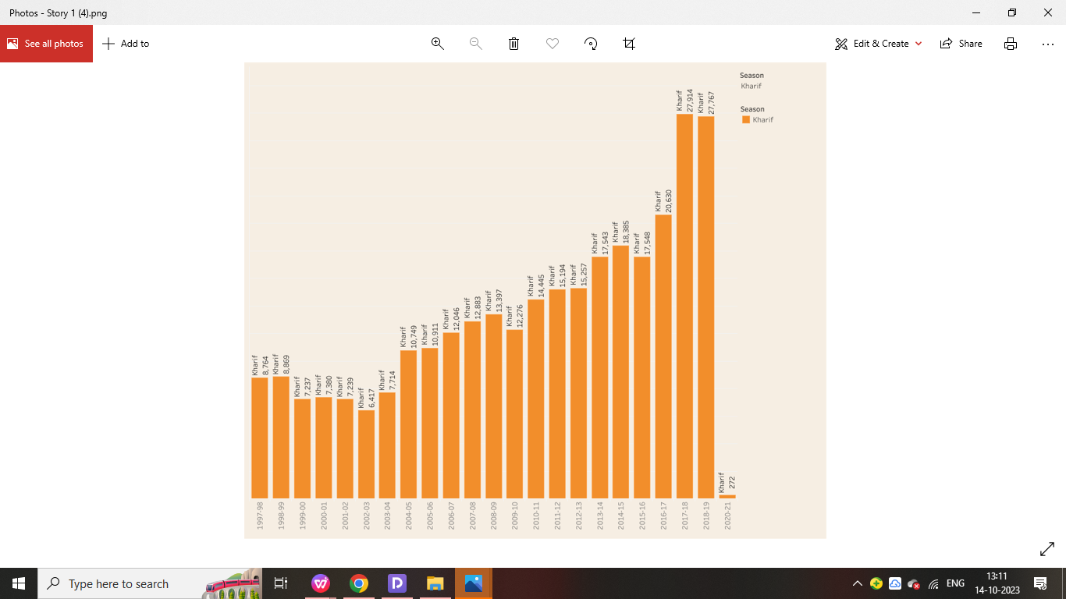

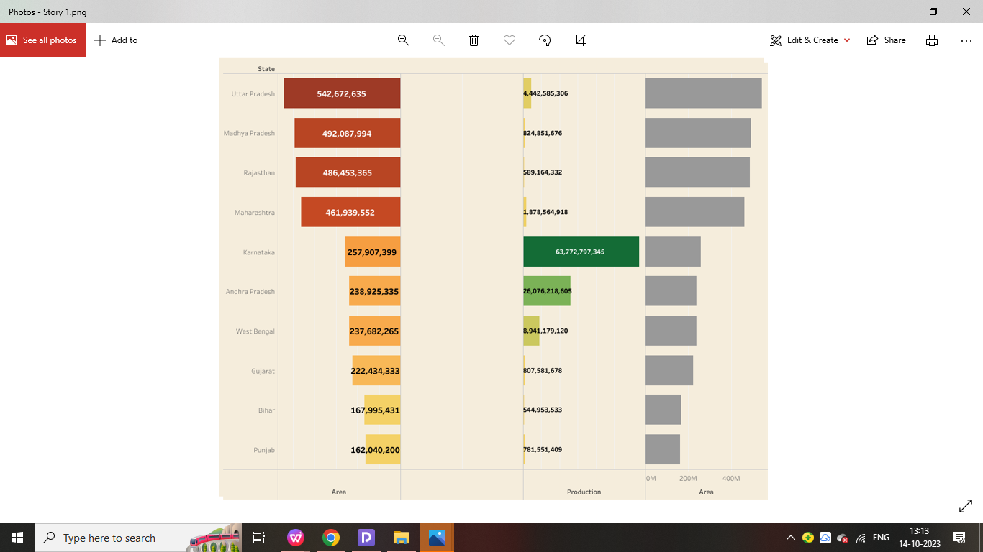

4: Advantages & Disadvantages

# Advantages

* It provides employment opportunity to the rural agricultural as well as non-agricultural labourers. It is the source of food and fodder. It also plays an important role in international business in import and export activities.
* the agricultural sector is one of the major contributors to Gross Domestic Product (GDP) and national income of the country

**# Disadvantages**

* Modern farming methods have overused the natural resource base.
* Increased use of fertilizers has led to the loss of soil fertility.
* The use of groundwater for tube well irrigation has led to water depletion

APPLICATION

* By using all these data and analysing the data’s we have learned the market’s situation in India.
* Using tableau we can visualize all the data’s for easy Understanding.
* Chief Minister K Palaniswami has launched the bi-lingual 'Uzhavan' (farmer) app here recently, an official release said today.
* AgriMarket mobile app can be used to get the market price of crops in the markets within 50 km of the device's location. This app automatically captures the location of person using mobile GPS and fetches the market price of crops in those markets which falls within the range of 50 km.
* Financial benefit of Rs 6000/- per year in three equal instalments, every four months is transferred into the bank accounts of farmers' families across the country through Direct Benefit Transfer (DBT) mode.

1. CONCULSION

Hereby we understand how to use tableau application

and analysing the given data. Using tableau application

we can create visualizations for easy understanding.

1. FUTURE SCOPE

* This proves that the agriculture sector is vital for survival highlighting the need for graduates with a degree in Agriculture.
* The future of agriculture is full of promise. Drones analysing the fields and algorithms predicting the harvest. The smart greenhouse doesn't require any staff as sensors and robots do the work.
* ndian agriculture can help the nation tackle three of its biggest challenges — feeding a huge and expanding population, ensuring sufficient energy supplies and curbing emissions. Still, meeting these goals will require a coordinated effort with alignment across policy, investment and agricultural research.